# **Department of Software Engineering**

# **Web Engineering**

# **Lab # 4**

## **Submitted by:**

## **UMER HASSAN KHAN**

## **Roll Number**

## **SP21020**

## **Submitted to:**

## **Ma’am Nabeela Bibi**

**TASK 1**

<!DOCTYPE *html*>

<html *lang*="en">

<head>

    <meta *charset*="UTF-8">

    <meta *name*="viewport" *content*="width=device-width, initial-scale=1.0">

    <title>Form</title>

</head>

<body>

      <form>

        <fieldset>

            <legend>Contact Infromation</legend>

            <label *for*="name">Name</label>

            <input *type*="text" *name*="name" *id*="name" >

            <br>

            <label *for*="email">Email</label>

            <input *type*="email" *name*="email" *id*="email">

            <br>

            <label *for*="password">Password</label>

            <input *type*="password" *name*="password" *id*="password">

        </fieldset>

        <fieldset>

            <legend>Additional Information</legend>

            <label *for*="gender">Gender</label>

            <input *type*="radio" *name*="male" *id*="gender">Male

            <input *type*="radio" *name*="female" *id*="gender">Female <br>

            <input *type*="checkbox" *name*="checkbox" *id*="checkbox">Subscribe to newsletter

            <br>

            <label *for*="country">Country</label>

            <select *name*="country" *id*="country">

                <option *value*="USA">USA</option>

                <option *value*="UK">Uk</option>

                <option *value*="Nepal">Nepal</option>

                <option *value*="Kenya">Kenya</option>

            </select>

        </fieldset>

<fieldset>

    <legend>Message</legend>

    <label *for*="message">Message:</label>

    <textarea *name*="message" *id*="message" *cols*="40" *rows*="05"></textarea>

</fieldset>

<label *for*="file">Upload a file:</label>

<input *type*="file" *name*="file" *id*="file"><br> <br>

<button *type*="reset">Reset</button>

<button *type*="submit">Submit</button>

    </form>

</body>

</html>

**Output**

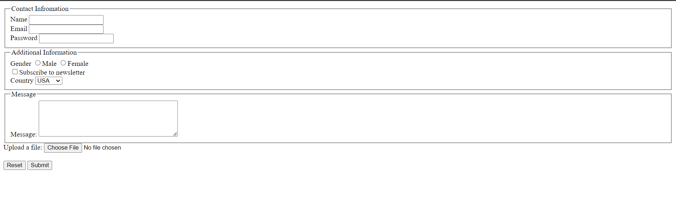

**TASK 2**

<!DOCTYPE *html*>

<html *lang*="en">

<head>

    <meta *charset*="UTF-8">

    <meta *name*="viewport" *content*="width=device-width, initial-scale=1.0">

    <title>List Orders</title>

</head>

<body>

    <h2>Nested Unordered lists</h2>

    <ul>

        <li>Coffee</li>

        <li>Tea

            <ul>

                <li>Black Tea</li>

                <li>Green Tea Tea</li>

            </ul>

        </li>

    </ul>

    <h2>Nested Ordered lists</h2>

    <ol>

        <li>Coffee</li>

        <li>Tea

            <ol>

                <li>Black Tea</li>

                <li>Green Tea </li>

            </ol>

        </li>

    </ol>

    </body>

</html>

**OUTPUT**

